Current Conduction in MOSFET

D. Mukhopadhyay
Dept. of Electronics and Telecommunication Engineering
Jadavpur University, Kolkata – 700 032
dmukho@yahoo.com

In order to obtain the relationship between the drain current of a MOSFET and its terminal voltages (drain and gate voltages), we make two observations.
- Consider a semiconductor bar carrying a current I. If the linear charge density along the direction of current is Q_{d} coulombs per meter and the velocity of the charge is v meters per second, then I = Q_{d} * v (1)
- Consider an n-FET whose source and drain are connected to ground. What is the charge density in the inversion layer? Since we assume the onset of inversion occurs at V_{GS} = V_{TH}, the inversion charge density produced by the gate oxide capacitance is proportional to (V_{GS} − V_{TH}). For V_{GS} ≥ V_{TH,} any charge placed on the gate must be mirrored by the charge in the channel, yielding a uniform channel charge density (charge per unit length) equal to Q_{d} = WC_{ox} (V_{GS} − V_{TH}) (2)
where C_{ox} is multiplied by W to represent the total capacitance per unit length.

Now let us suppose, the drain voltage is greater than zero. Since the channel potential varies from zero at the source to V_{D} at the drain, the local voltage difference between the gate and the channel varies from V_{G} to V_{G} − V_{D}. Thus the charge density at a point x along the channel can be written as
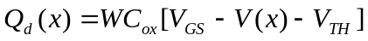 (3)
where V(x) is the channel potential at x.
From Eqn (1), the current is given by
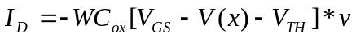 (4)
where the negative sign is inserted because v denotes the velocity of the electrons in the channel and is in opposite direction to the current flow.

For semiconductors v = μE, where μ is the mobility of the charge carriers and E is the electric field. Noting that E(x) = − dV/dx and representing the mobility of the electrons by μ_{n}, we have
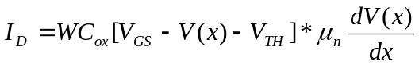 (5)
subject to boundary conditions V(0) = 0 and V(L) = V_{DS}.
While V(x) could be obtained from this equation, the quantity of interest is in fact I_{D}, which is independent of x. Multiplying both sides of Eqn (5) by dV and performing the integration, we obtain
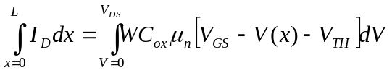 (6)
Since I_{D} is constant along the channel
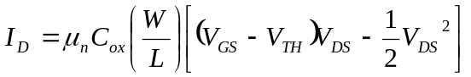 (7)
Note that L is the effective channel length and not the geometrical (drawn) channel length.

We also note that the drain current in a MOSFET is determined by three parameters:
- The technology parameter, μ_{n}C_{OX}, which depends on the fabrication process and technology.
- The design (geometrical) parameter (W/L) which is the ratio of the width to the length of the channel. The channel length is fixed by the lithographic process parameter and is usually referred to as “scaling” to a particular technology node. The designer controls the drive current by suitably choosing the channel width, the method usually called “transistor sizing”.
- The two terminal voltages, V_{DS} and V_{GS}. The designer and the user control the current by these two voltages.
Fig. 1 plots the parabolas given by Eqn (7) for different values of V_{GS}, indicating that the current capability (drive current) of the device increases with V_{GS}. By calculating 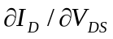, we can show that the peak of each parabola occurs at V_{DS} = V_{GS} − V_{TH} and the peak current is
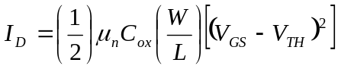 (8)

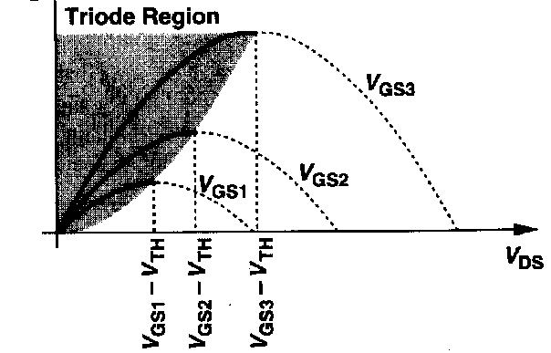
Fig. 1 Drain current versus drain voltage in the triode region

According to Eqn (7), beyond this peak, the current should decrease with V_{DS}. But we have already noted that for values of V_{DS} in excess of V_{GS} − V_{TH}, channel pinch-off occurs and the conditions under which Eqn (7) was derived no longer remain valid. We have also noted that beyond pinch-off the drain current gets saturated and shows no further increase with increasing V_{DS}. We, therefore, do not evaluate the current beyond the pinch-off point and assume that for values of V_{DS} greater than V_{GS} − V_{TH}, the current is maintained at the same value as at V_{DS} = V_{GS} − V_{TH} and is obtained from Eqn (7) by substituting V_{DS} by V_{GS} − V_{TH}. This current, beyond channel pinch-off, is thus given by Eqn (8) and is independent of V_{DS}.

We call (V_{GS} − V_{TH}) the “overdrive voltage” and W/L the “aspect ratio.” If V_{DS} < (V_{GS} − V_{TH}), we say the device operates in the “triode region” or the “linear region”. Beyond this point, it operates in the “saturation region”.

Equations (7) and (8) serve as the foundation for analog CMOS design, describing the dependence of I_{D} upon the constants of technology μ_{n}C_{ox}, the device dimensions, W and L, and the gate and drain potentials with respect to the source. It is to be noted that the integration in Eqn (7) assumes μ_{n} and V_{TH} are independent of x and the gate and drain voltages. These approximations are surely not valid when the device dimensions reach below submicron level and the operating electric field becomes large. The current equations then need modifications and may even a reformulation.

The linear region (voltage variable resistor)
If in Eqn (7), V_{DS} << 2(V_{GS} − V_{TH}), we have
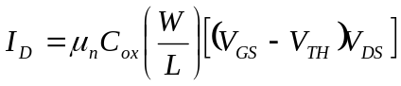 (9)
that is, the drain current is a linear function of the drain to source voltage, V_{DS}. This is also evident from the characteristics shown in Fig. 2. For small V_{DS} the I-V characteristics can be approximated by straight line.
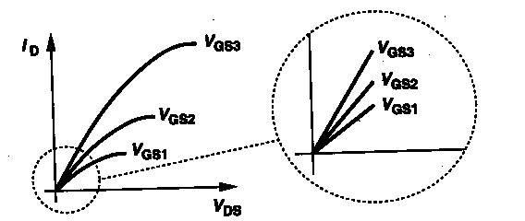
Fig. 2. Linear characteristics in the deep triode region

The linear relationship implies that the path from the source to the drain is represented by a linear resistor equal to 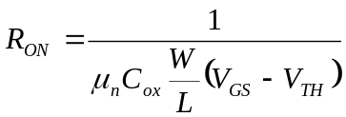 (10)
A MOSFET can, therefore, operate as a linear resistor whose value is controlled by the overdrive voltage, as long as V_{DS} << 2(V_{GS} − V_{TH}). With the condition, V_{DS} << 2(V_{GS} − V_{TH}), we say the device operates in deep triode region.

The saturation region (constant current generator)
For V_{DS} ≥(V_{GS} − V_{TH}), the drain current saturates at the value given by Eqn. (8). The drain current becomes independent of the drain to source voltage, but is controlled by the gate to source potential. Hence the MOSFET operates as a voltage-controlled constant-current generator as long as V_{DS} exceeds the gate overdrive (V_{GS} − V_{TH}). This is shown in Fig. 3. The drain current dependence on the gate overdrive voltage follows a square law relation. For this reason, a MOSFET is often referred to as a square-law device.

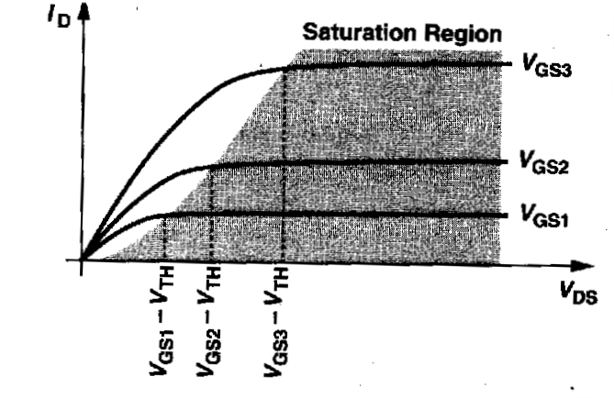
Fig. 3 Saturation of drain current

The current in the saturation region is independent of the drain voltage, V_{DS} to a first order of approximation. The value of the drain current when V_{GS} = V_{DS} = V_{DD} is referred to as the drive current. This is the maximum current that can be obtained from the transistor for a given supply voltage.
The current in the saturation region is controlled by the gate-to-source potential. The corresponding figure of merit should be the transconductance, g_{m}, given by
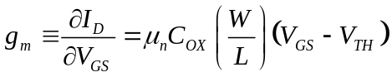 (11)
In a sense, g_{m} represents the sensitivity of the device: for a high g_{m}, a small voltage change at the gate results in a large change in the drain current. Interestingly, it is also noted that the transconductance value in the saturation region is equal to the inverse of the on-resistance in the deep triode (linear) region.

The transconductance, g_{m} can also be expressed as
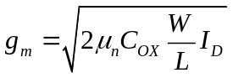 (12)
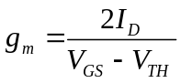 (13)
Each of the above three expressions proves useful in studying the behavior of g_{m} as a function of one parameter while the other parameters remain constant.

Equation (11) suggests that g_{m} increases with the overdrive if (W/L) is constant (Fig. 4), whereas Eqn, (13) implies that g_{m} decreases with the overdrive if I_{D} is constant (Fig. 6). Equation (12) suggests g_{m} increases as 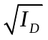 if W/L is held constant (Fig. 5).
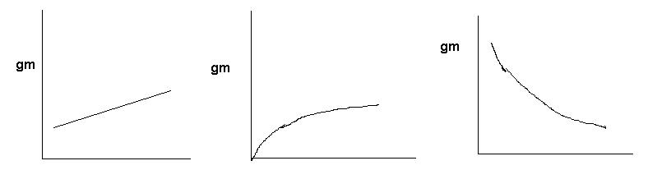
(V_{GS} − V_{TH}) → I_{D} → (V_{GS} − V_{TH}) →
Fig. 4 Variation of g_{m} with overdrive, Fig. 5 Variation of g_{m} with I_{D} Fig. 6 g_{m} with overdrive
(W/L) kept constant (W/L) kept constant I_{D} kept constant

The concept of transconductance can also be applied to a device operating in the triode (linear) region. In this case, the transconductance increases linearly with the drain-to-source potential, V_{DS}.
In the linear region,
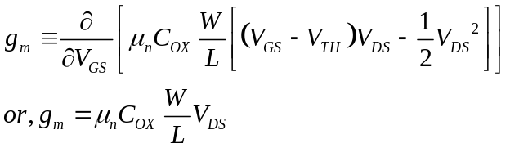
In the linear region, g_{m} increases linearly with V_{DS} and reaches a maximum, saturated value when the transistor reaches saturation at V_{DS} = V_{GS} − V_{TH}.

Second Order Effects
There occurs many second order effects in the current conduction process in a MOSFET structure when the applied electric field along the channel or the perpendicular field due to the gate voltage is large and/or when the transistor is scaled down such that the channel length is very small. These are the (i) high-field or hot-electron effects and (ii) short-channel effects.
The two important second-order effects that have been considered in all but the rudimentary Sah’s model (also called the “students’ model”) are
(i) Channel length modulation (CLM) and (ii) Body bias effect

(i) Channel length modulation
The inversion charge per unit length at the source end of the channel is given by
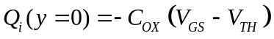 (1)
The inversion charge per unit length at the drain end of the channel is given by
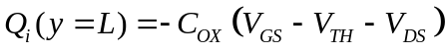 (2)
It looks like when V_{DS} is increased to V_{GS} − V_{TH}, the inversion layer charge at the drain end becomes zero. This is the so-called pinch-off condition. In reality, however, the channel charge does not become zero, but indeed becomes very small
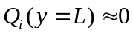 (3)
This is the onset of current saturation condition. This is signified by the condition when the channel becomes pinched-off at the drain end and this occurs at the drain voltage V_{DS} = (V_{GS} − V_{TH}). Thus V_{DS, Sat} = (V_{GS} − V_{TH}).

When the drain voltage is increased further beyond this saturation edge, i.e. V_{DS} > V_{DS, Sat}, larger portion of the channel becomes pinched-off and the pinch-off point moves slightly towards the source end of the channel and the effective channel length (the length of the inversion layer where the “gradual-channel approximation” is still valid) is reduced to
L/ = L − ΔL
where ΔL is the length of the channel segment with Q_{i} ≅ 0.

Since Q_{i} (y) = 0 for L/ <y< L, the channel voltage at the pinch-off point remains equal to V_{DSat}, i.e.
V_{i} (y=L/) = V_{DSat}. Now the inverted portion of the channel is represented with a shortened length of L/, with a channel-end voltage of V_{DSat}. The current, therefore, is given by
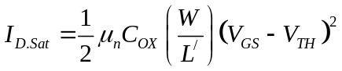
or 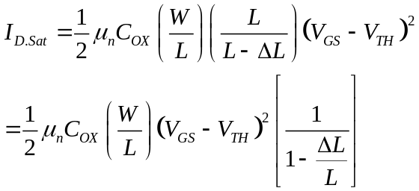 (4)
We note that the shift of the pinch-off point, ΔL will be proportional to the applied drain voltage, V_{DS} and use the empirical relationship
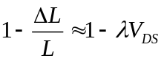
where λ is an empirical parameter and is called the channel-length modulation parameter. The current equation can now be written as
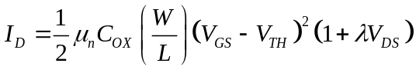 (5)
The channel length modulation (CLM) parameter λ is controlled by the technology of fabrication. Its value is also inversely proportional to the channel length.

(ii) Body bias effect
For an n-channel MOSFET, the bulk is p-type and the induced inverted channel is n-type. When the bulk is at a lower potential than the source, the bulk (p-type) to channel (n-type) depletion region widens (p-type less positive than n-type). This results in more depletion charge. Since the sum of depletion charge and the inversion charge is to be balanced by the gate charge induced by the positive gate voltage, i.e.
gate oxide charge = depletion charge + inversion charge.

An increase in the depletion charge then necessarily reduces the inversion charge. More gate potential is now needed to create the same amount of inversion charge.
The threshold voltage is phenomenologically defined as the gate potential for which the inversion charge equals at least the background doping. This is the accepted condition for strong inversion.

Thus reverse biasing the bulk (bulk negative with respect to source) increases the depletion charge. To maintain charge balance, the inversion charge gets reduced. To bring back the inversion charge back to the threshold level, the gate potential needs to be increased. Thus, the threshold voltage increases for an n-channel MOSFET when we reverse bias the source-bulk junction (bulk more negative than source).
Thus for an n-channel MOSFET:
Bulk more negative than the source ⇒ Increase in depletion charge ⇒ Reduction in inversion charge ⇒ More gate voltage needed for inversion threshold ⇒ Threshold voltage increases.

Opposite arguments will show that for a p-channel MOSFET, the threshold voltage will get reduced when the bulk is more negative than source.
Thus for a p-channel MOSFET:
Bulk more negative than the source ⇒ Decrease in depletion charge ⇒ Increase in inversion charge ⇒ Less gate voltage needed for inversion threshold ⇒ Threshold voltage decreases.

The threshold voltage in the presence of body-bias, V_{SB} is given by
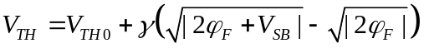 (6)
where φ_{F} is the Fermi potential.
Memo
Body Biasing | n-channel | p-channel
Forward biasing of source-bulk (bulk more positive) | Threshold voltage gets reduced | Threshold voltage gets increased
Reverse biasing of source-bulk (bulk more negative) | Threshold voltage gets increased | Threshold voltage gets reduced
These arguments are valid for the enhancement mode of operation. For depletion mode operation, threshold voltage is likely to be insensitive to the source-bulk potential.

